Git Tools

To explore the robust functionality of Git, we need some tools. Git comes with some of its tools like Git Bash, Git GUI to provide the interface between machine and user. It supports inbuilt as well as third-party tools.

Git comes with built-in GUI tools like **git bash**, **git-gui**, and **gitk** for committing and browsing. It also supports several third-party tools for users looking for platform-specific experience.

Git Package Tools

Git provides powerful functionality to explore it. We need many tools such as commands, command line, Git GUI. Let's understand some essential package tools.

GitBash

Git Bash is an application for the Windows environment. It is used as Git command line for windows. Git Bash provides an emulation layer for a Git command-line experience. Bash is an abbreviation of **Bourne Again Shell**. Git package installer contains Bash, bash utilities, and Git on a Windows operating system.

Bash is a standard default shell on Linux and macOS. A shell is a terminal application which is used to create an interface with an operating system through commands.

By default, Git Windows package contains the Git Bash tool. We can access it by right-click on a folder in Windows Explorer.

Git Bash Commands

Git Bash comes with some additional commands that are stored in the **/usr/bin** directory of the Git Bash emulation. Git Bash can provide a robust shell experience on Windows. Git Bash comes with some essential shell commands like **Ssh**, **scp**, **cat**, **find**.

Git Bash also includes the full set of Git core commands like **git clone, git commit, git checkout, git push**, and more.

Git GUI

Git GUI is a powerful alternative to Git BASH. It offers a graphical version of the Git command line function, as well as comprehensive visual diff tools. We can access it by simply right click on a folder or location in windows explorer. Also, we can access it through the command line by typing below command.

1. $ git gui

Git Tools

A pop-up window will open as Git gui tool. The Git GUI's interface looks like as:

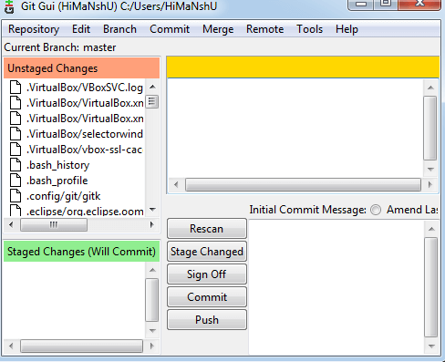

Git facilitates with some built-in GUI tools for committing (git-gui) and browsing (gitk), but there are many third-party tools for users looking for platform-specific experience.

Gitk

gitk is a graphical history viewer tool. It's a robust GUI shell over **git log** and **git grep**. This tool is used to find something that happened in the past or visualize your project's history.

Gitk can invoke from the command-line. Just change directory into a Git repository, and type:

1. $ gitk [git log options]

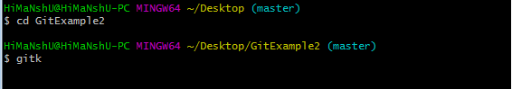

This command invokes the gitk graphical interface and displays the project history. The Gitk interface looks like this:

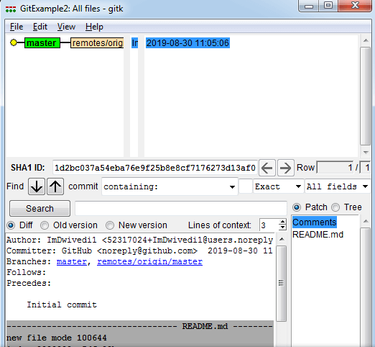

Gitk supports several command-line options, most of which are passed through to the underlying git log action.